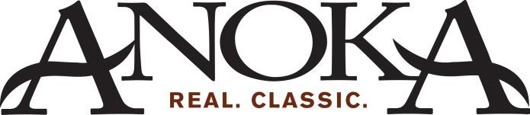

Community Development Department
City of Anoka ● 2015 First Avenue ● Anoka, MN 55303
www.anokaminnesota.com

Property Owner Guidance for Vegetation Clearing Permits in the Mississippi River Corridor Critical Area (MRCCA)

Intensive vegetation clearing in many areas of the MRCCA needs a permit. The permit requires that removed vegetation be replanted through a restoration plan. A restoration plan is also required upon failure to obtain a vegetation clearing permit when one is required. This guidance explains when to apply for a vegetation clearing permit and how to complete the permit application, including a vegetation restoration plan.

Does all vegetation removal in the MRCCA require a permit?
No, common activities such as maintaining existing lawns, landscaping and gardening do not require a permit. Additionally, selective vegetation removal - the removal of only isolated individual trees and shrubs that does not substantially reduce the tree canopy or understory cover - is allowed anywhere in the MRCCA without a permit.
The MRCCA is a corridor of land along each side of the Mississippi River in the Twin Cities Metro Area with coordinated state, regional and local land use planning and zoning. Vegetation removal is regulated through a local permit to protect the corridor’s scenic, natural, and recreational features.
The purpose of the permit is to help property owners remove and restore vegetation in a manner that sustains natural character and animal habitat, and stabilizes slopes.

When is a permit required?
A permit is required for any intensive vegetation clearing - the removal of all or a majority of the trees or shrubs in a contiguous patch, strip, row, or block - in areas known as Primary Conservation Areas (PCAs). PCAs include:
- The shore impact zone: Land within 50% of the required structure setback from the river.
- The bluff impact zone: A bluff and land within 20 feet of a bluff. A bluff is a natural feature with a minimum 25 ft. height and an average slope exceeding 18%.
- Native plant communities: Plant communities of five acres or greater that meet the quality criteria established by the Minnesota Biological Survey to qualify as a native plant community.
- Significant existing vegetative stands: Largely intact and connected plant communities that contain a sufficient representation of the original native plant community.
- Areas within 50 feet of a wetland or natural drainage route.

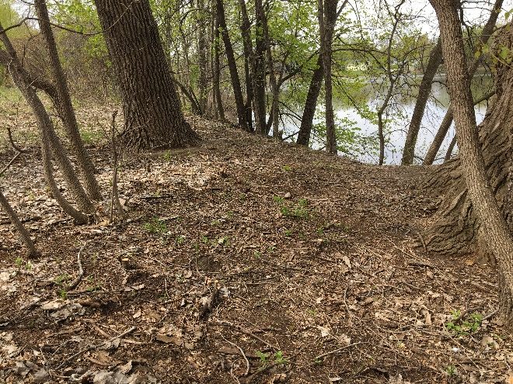
Selective vegetation removal is the removal of only isolated individual trees and shrubs that do not substantially reduce the tree canopy or understory.
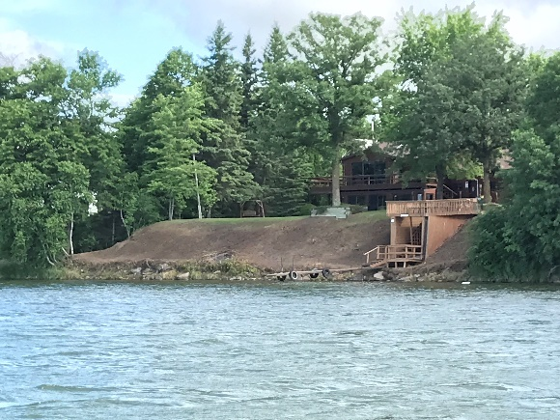
Intensive vegetation clearing is the removal of all or a majority of the trees or shrubs in a contiguous patch, strip, row, or block.

Can I get a permit for ANY intensive vegetation clearing within PCAs?
No, intensive vegetation clearing is only allowed for the following purposes:
- Clearing vegetation that is dead, diseased, dying, or hazardous or to prevent the spread of diseases or insect pests.
- Clearing to remove invasive non-native species.
- Clearing to prepare for restoration and erosion control management activities consistent with a plan approved by (insert name of resource agency LGU has identified as responsible).
- The minimum clearing necessary for development allowed with a building permit or allowed as an exemption under Section 12 (insert local ordinance reference) of the (name for ordinance).
Within PCAs, all other intensive vegetation clearing is prohibited.

How do I know if my property contains PCAs?
The DNR’s online PCA mapper shows the location of common PCAs. After opening the online mapper, enter your property address in the search box. The online mapper will then zoom in to your
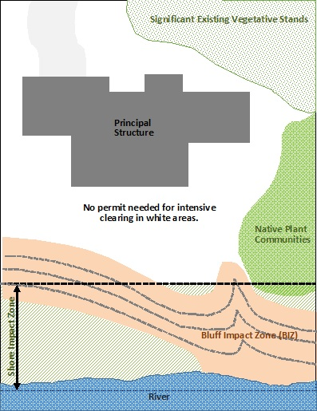
Intensive vegetation clearing within PCAs requires a vegetation clearing permit
property and you will be able to see if there are any PCAs on your property. PCAs are identified in the map legend.

What does a vegetation clearing permit application include?
The application form includes questions about where vegetation clearing will occur, the purpose of the vegetation clearing, the type and quantity of removed vegetation, and how vegetation removal will be designed and phased to minimize erosion and impacts to natural resources and scenic views.
The application form requires applicants to develop a restoration (or planting) plan. Developing the restoration plan is the most significant part of the application. Restoring vegetation in the same location as that removed may or may not be possible or desirable depending on the reason for removing the vegetation, and other priority areas or opportunities for restoration. The application asks applicants to assess their property to identify if any of the following three “restoration priority areas” exist:

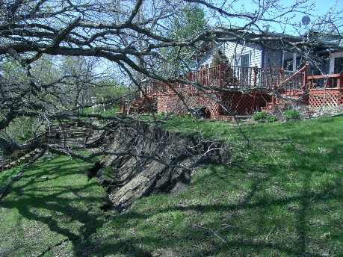
1. Areas with soils showing signs of erosion, especially on or near the top and bottom of steep slopes and bluffs.
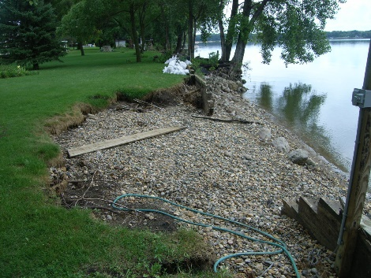
2. Shoreline areas within 25 feet of the water with no natural vegetation, degraded vegetation, or planted with turf grass.
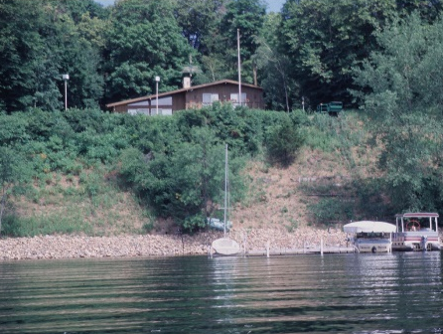
3. Steep slopes and bluffs visible from the river with no natural vegetation, degraded vegetation, or planted with turf grass.
If any of these restoration priority areas exist, then they will be the focus of the restoration plan. If none of these areas exist, applicants must propose other opportunity areas that could benefit from restoration. For ideas of other areas to restore, consult local zoning staff and the restoration priorities map in the (insert city or town name) MRCCA plan.

What are the restoration plan performance standards?
All restoration (or planting) plans must meet the following performance standards:
- Restored vegetation is planted in one or more of the identified restoration priority or opportunity areas.
- Restored vegetation provides suitable habitat, and effective soil stability, runoff retention, and infiltration capability relevant to the priority or opportunity area. For example, shoreline areas with turf grass should be restored with a mix of ground cover, understory vegetation and trees providing habitat/pollinators and soil stabilization. The vegetation species, composition, density, and diversity of restored vegetation must be guided by nearby patches of native plant communities. Use the DNR’s Native Plant Encyclopedia plant selector to select plants that are suitable for your specific site conditions and county.
- Highly erodible soils disturbed during removal and/or restoration are stabilized by deep-rooted vegetation with a high stem density.
- The area (sq. ft.) of the restored vegetation is similar to that removed to the greatest extent practicable.
- For restoration of removed native plant communities, restored vegetation must also provide biological and ecological function equivalent to the removed native plant communities. The restored area (sq. ft.) should be equivalent in area to that of the vegetation removed.

The Native Vegetation Establishment and Enhancement Guidelines is a comprehensive guide for planning, implementing, and maintaining native plant community restoration plans. It contains good advice and considerations for any type of restoration plan.

What are the permit application submittal requirements?
A complete permit application includes:
- An aerial photo and/or site plan showing:
- Property boundaries
- Location of existing PCAs
- Location and area (sq. ft.) of the vegetation proposed to be cleared within PCAs
- Location and area (sq. ft.) of the restored vegetation in the restoration priority areas

- Photos of the vegetation proposed for removal.
- A restoration (or planting) plan(s) for the identified restoration priority or opportunity area(s) showing the location, type (ground cover, understory, tree) and name of proposed plants.

Note: Aerial photos printed from the DNR’s online PCA mapper (see example to the right) show property boundaries and PCAs. The locations of the vegetation proposed to be cleared and restored can be shown on these aerial photos with hand drawings. Detailed site plans, including a survey, may be needed for more complex projects.

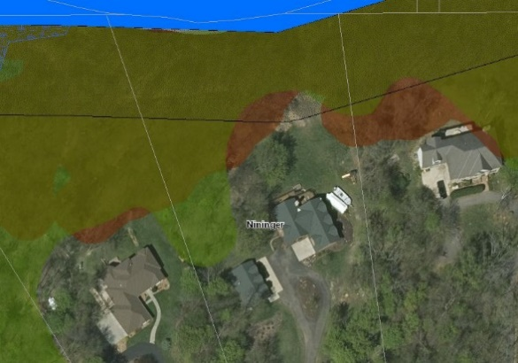
Example of aerial photo from DNR’s online PCA mapper.

How does the size and complexity of the project affect review and approval?
In most cases, property owners will be able complete their own restoration plan provided the project is relatively small, no native plant communities are being removed (this is rare) and the restoration plan meets performance standards. If zoning staff determines that the plan does not meet the performance standards, a qualified landscape professional may be needed.

Large, complex projects, including but not limited to native plant community restorations, require more detailed information and scaled drawings and should be prepared by an experienced landscape designer or architect. For larger projects, a detailed three-year maintenance plan that includes provisions for controlling invasive species and plant replacement is required. For native plant community restorations, applicants will need to identify the type and location of the native plant community used to guide the restoration.

If you are uncertain about the level of restoration plan needed for your vegetation clearing project or how to meet performance standards, it is a good idea to consult zoning staff early in the process.

What happens when I submit my permit application?
Planning staff will review the application to make sure it is complete and that all PCAs and restoration priority areas have been identified. Staff will also review to ensure that the vegetation clearing is the minimum necessary and designed to blend with the natural terrain and minimizes impacts to scenic views. Finally, they will look at the restoration plan to ensure it meets the performance standards.
If the permit application is complete and meets the performance standards, the permit will be approved. Standard conditions of approval require that:

- the work be completed consistent with the submitted application and by a specific date,
- the restored vegetation be maintained for three years, including control of invasive species, and
- photos of the completed project be submitted.

Once the permit is approved, work may proceed. When photos of the completed project are submitted, a certificate of compliance will be issued. Local officials may enter the property, during normal business hours, for up to three years after the date of the certificate of compliance to verify that the restored site is being maintained consistent with the conditions of approval.

